Şennur Eçmen
Mine Tekkartal
Sena Tepebağlı
Kadın Emeğini Değerlendirme Vakfı (KEDV)
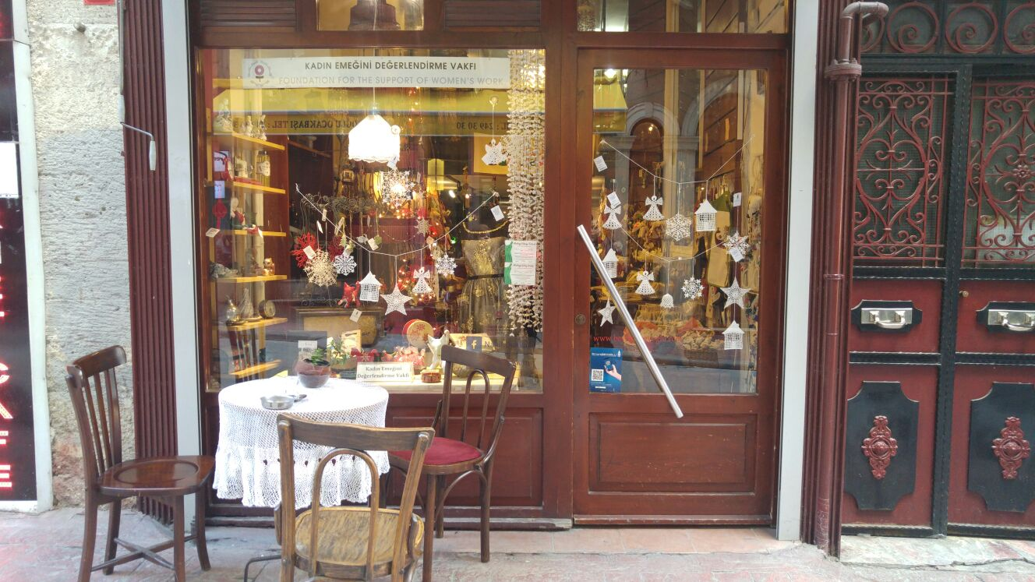
Vakıfa üye olan kadınların çalışmalarının sergilendiği ve satışa sunulduğu yer
- Kuruluşun Tanıtım
- Kuruluşun Amacı
Kadın Emeğini Değerlendirme Vakfı (KEDV), kadınların ekonomik durumlarını ve yaşam kalitelerini iyileştirmek amacıyla 1986’da kurulmuştur. Düşük gelirli bölgelerdeki kadınların bireysel ve toplumsal yaşamlarını iyileştirme çabalarını desteklemek, temel ihtiyaçları etrafında organize olarak potansiyellerinin farkına varabilecekleri alanlar yaratmak ve çocukların erken çocuk eğitimi olanaklarından yararlanabilmelerini sağlamak üzere faaliyetlerini yürütür. Kadın gruplarına yönelik bireysel ve kolektif kapasite geliştirme ve ekonomik güçlendirme programları uygular, bu gruplara Kadın ve Çocuk Merkezleri kurarak erken çocukluk eğitim hizmetleri sunmaları için destek verir.
- Faaliyetleri
Vakıf, kadınlar açısından öncelikli olduğuna inandığı 4 temel konuda programlar geliştirmiş ve uygulamaktadır. Aynı zamanda bu programların yerel kadın grupları tarafından yaygınlaştırılmasına destek vermektedir.
- Erken Çocukluk Eğitimi
- Ekonomik Güçlendirme
- Kapasite Geliştirme
- Afete Hazırlık Programı
...
…
…
- Kuruluşun faaliyetlerinin Teorik Bağlamı
Model of Guralnick
According to Model of Guralnick family characteristics and family patterns have big impact on both the children and families. He included quality of parent-child transaction, family orchestrated child experiences and health and safety provided by family in family patterns. For developing these and effective early intervention we can use resource, social and information and services according to him. When we look at the KEDV’s intervention programs, we can see that they usually work with women because KEDV believes in that women who have seen as a minority group have more stressors than everbody elses. The patriarchal system and its effects on women, women without economic freedom, lack of education, the inequality in business life are just the first things that spring to mind as a stressors for women. After determining these stressors, when we look at the association’s early intervention program components, we can first see the resource supports. They provide training for mothers and children. For example they work with Kadıköy Belediyesi in these days and they assist women in the cooperation process. They have some education seminars which mostly focus on product development. But in general the main purpose of these trainings is to promote participatory education. They want that everbody in a family can take their own responsibilities. Also when we look at their social supports, we can see lots of practices about it. When women try to be stronger and developed themselves, they already find them in a very large community networks. They try to become a cooperative and everybody in this cooperative have similar consequences. They try to support each other. For example in one of the KEDV’s study in Adana they gave technical course for women. Then, they realized that if there are women, there are children also. So, they created a game room for children in the center where the course is given. They found teachers for every game room and they included children in this study. After that, they developed a new concept which known as a ‘mahalle anneliği’. Neighborhood motherhood is about babysitting for working mothers. They take care of children for a nominal fee. Women who have children but also want to work can easily trust the neighborhood mother because she is already well-known and live in the same neighboorhood. A neighborhood mother can also takes care of more than one children. Also she visits the home in a certain time period, gives parents information about child or gives them advices. It is like a family counseling.
Lastly, when we think about information and services support, KEDV cannot find an opportunity to giving this support yet. However, their future plans include using parent-professional realitonship because they will work with Syrian Refugees and they believe in that it can be beneficial to using this kind of a guidance.
Transactional Model of Sameroff
According to Sameroff’s Transactional Model, the role of the environment in affecting child development and have argued that planning affective interventions requires a sophisticated view of environmental action that includes attetion to many factors. Developmental outcomes are neither a function of the individual alone nor of the experiential context alone. Outcomes are a product of the combination of an individual and his or her experiences. Sameroff separates child behavior in three groups like genotype, phenotype and environtype. Genotype refers to each person’s genetic characteristics, phenotype is about the physical appearance of people. Environtype also can be divided in three groups. These are family code, cultural code and parenting code. When we analyze the KEDV perspective we can say that KEDV especially focuses on cultural code. Cooperative projects of the KEDV located in Biga and Urla are more successful in order to both raise awareness promote especially mothers. Because culture are the determinant factor to mention about cultural code. In addition, in our culture women raise a child while men earn money. However, KEDV wants to break the chain and encourage mothers in order to involve themselves in economic activities by creating home made products. Besides, contribution of fathers are also so important in this process. Their participation support mothers not to ignore themselves because of mothers responsibilities that are determined by culture. Women think that thet cannot work because there is no one to care their children. However, KEDV supports women in order to overcome these all stereotype ideas.
Sameroff also focuses on remediation, redefinition and reeducation. Remediation changes the way the child behaves towards the parent. However, KEDV does not focus on children and the changes of their behaviors. So we can say that KEDV does not have any contribution for remediation. Redefinition changes the way the parent interprets the child’s behavior. KEDV plans trainings and courses for women to include women in business word. The trainings gains technics to create some products to enhance their economic income, how they should behave towards their children and how families can provide their children’s development by economic freedom. In the light of the trainings women establish cooperatives to league together. They can get strong by coming together. In that point, we can emphasize reeducation that enhances the way the parent behaves toward the child. Because KEDV says that if there is a woman there should be a child too. For that reason, while mothers get trainings KEDV established game rooms and fairytale houses.
To conclude, KEDV adapts itself according to Sameroff Transactional Model by focusing on cultural code, redefinition and reeducation. While women are at the center of the KEDV, children alson important for this foundation. Because, “If there is a woman there is a child.”
Brofenbrenner’s Ecological System Theory
For the Brofenbrenner’s Ecological System Theory, there are four circles which represent four environment types. There are macrosystem,exosystem, mesosystem and microsystem. Firstly, microsystem is the smallest area which include child, parents, school or neighborhood. KEDV tries to support mother-child relationship with some intvention programs such as early childhood education. With this program they try to reach low-income families and get well to families’ lives standards. They want to ensure not only education but also care giving to children with their mother. Thanks to education with mother and child, they also increase the effectivenes of mother-child interactions. Also, they try to support the relationship between child and neighbors. They have a project which is named “mahalle anneliği”. Neighborhood mother takes care of children’s needs and cares on her districts. They wants to get well children’s primary environment. Second circle is mesosystem. Mesosystem is regulatory for relationships of members in microstytem. For instance KEDV and mothers work together and cooperate each other for positive development of children. Mothers also meet and know the other children and their parents in cooperatives. This is also effective way to strength relationship in microsystem’s members with the help of mesosystem’s intervention. In exosystem, children do not play a direct role but things in there have a direct role of children’s lives. For example KEDV cooperate the institutions for developing mother and child’s living conditions. In this examples, child has no direct role but this cooperation affect directly to child’s life experiences. Lastly, exosystem includes the other people and other places such as work places of families. For KEDV, women are in disadvantage group in society which seems like powerless. This beliefs of powerlessness of women affects being mother. Society believes that women are insufficent for working and their missions is that they should take care of their children at all the time. KEDV try to focus on women and also mothers economic power and try to ameliorate this situation. So, children are also affected this intervention and support. For KEDV future plan, they will focus on Syrian refugees. They point that the government make decision for permanence of Syrian refugees in Turkey. Therefore, they want to start a new intervention programs for Syrian refugees mothers and their children. All in all, Brofenbranner focuses on not only the mother and father but also multiple risk factors such as their working environment or governments’ laws. He wants to provide an intervention programs for multiple risk factors.
Resilience
What about resilience? Resilience as a process not a quality, charateristic or cause, it is an ongoing process. Resilient children who have good developmental outcomes from high-risk backround like enocomic hardship and overcome great odds. For supporting the resilience KEDV firstly support mothers because mothers are the first factor that is neccesary for the resilience of children and they know that mothers are primary care givers. As we know the most important factor that determines the level of vulnerability or resiliency is the positive developmental history and protective factors. For KEDV there are many risk factors in our society. One of the risk factor that affects children’s resiliency is powerlesness of woman because being a women comes first from being a mother. Above all a mother is a woman and KEDV thinks that they impower the women. To do this, they support them for becoming a cooperative. They try to sell women’s works because they want them to be economically free. Also they give importance to effective reliationship with primary caregivers. For example, when they give education seminars to mothers, they set place as a game room for children. So children do not separate from their mothers during the seminars. It is believed that working mothers fall between two tools which are their job and child care. Besides this perception of society, KEDV tries to compensate this with neigborhood mothers who take care of children when their mothers work.
Also KEDV has an intervention program about child labor issue. They pitched a support tent for children who have to work as a seasonal agricultural workers in Mardin. They played games and satisfied their basic needs in that tent. Project officer Gökçesu Özgül said that “We wanted to change their lives even if we could do for a day.” This is one of the protective factor which provided by KEDV for at-risk group of children.
In short, we can say that there are some intervention programs to develop resiliency in KEDV. Although risk factors sometimes can be challenging, they try to increase the number of protective factors and provide positive developmental history. So, children can bounce back.

